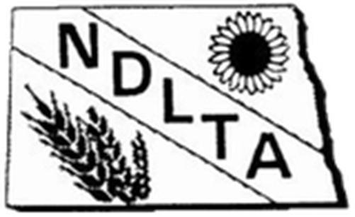
NORTH DAKOTA LAND TITLE ASSOCIATION
2021 ANNUAL CONVENTION
September 16th through 18th, 2021
TENTATIVE AGENDA

Resilience & Reinvention

Radisson Hotel

6th & Broadway

Bismarck, ND 58501

THURSDAY, SEPTEMBER 16th

11:00 am to 12:30 pm Registration
1:00 pm to 2:00 pm Welcome
2:00 pm to 2:15 pm Break
2:30 pm to 3:30 pm Speaker- ALTA
3:30 pm to 3:45 pm Break
3:45 pm to 4:45 pm Speaker
5:30 pm to 6:30 pm Social Hour
6:30 pm to 8:00 pm Dinner
8:00 pm to midnight Brent Reed- Heavyweight of Clean Comedy

FRIDAY, SEPTEMBER 17th
7:00 am to 9:00 am Breakfast
8:00 am to 9:00 am Registration
9:00 am to 10:00 am Business Meeting Part 1
10:00 am to 10:30 am Break
10:30 am to 12:00 pm 9/11- A NYPD First Responder’s Story
12:45 pm to 4:45 pm Golf and lunch- Riverwood Golf Course
Art and lunch/wine- Theo Art School
5:30 pm to 6:30 pm Social Hour
6:30 pm to 8:00 pm Dinner
8:00 pm to Midnight Musical Entertainment- Sugar Break

SATURDAY, SEPTEMBER 18th
7:00 am to 9:00 am Breakfast
9:00 am to ?? Business Meeting and Committee Reports

